Problem 2: Gradient Descent for regression

Part 1

Learning curve for training and validation set is given below:

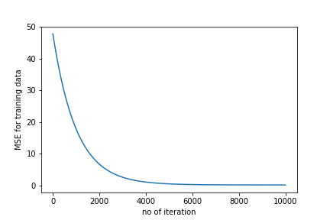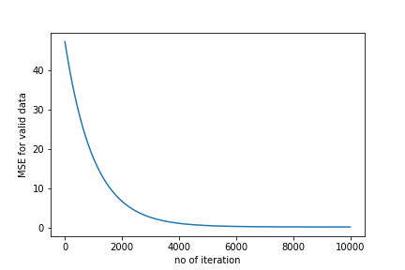

Fig: Learning curve for training data Fig: Learning curve for training data

Part 2

For different value of step size / learning rate MSE is given below

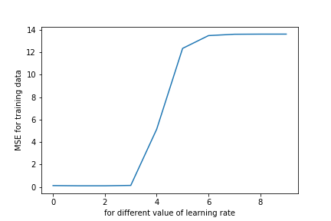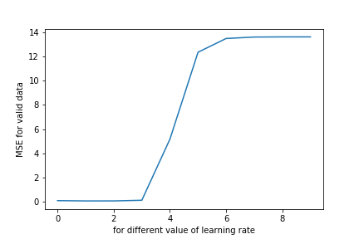

Fig: MSE on training data for varying step size / learning rate Fig: MSE on validation data for varying step size / learning rate

As we see for learning rate/ step size = 0.001 we get the least MSE in both training and validation, it's the best learning step

Test MSE for lambda = 0.001 is 0.09820181276743561

Part 3

I used the fit on TEST SET as I train the model for 100 epochs

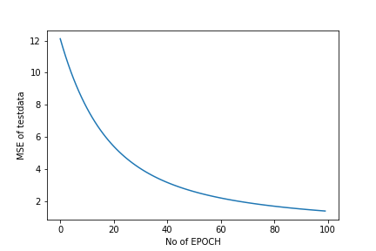

Fig: MSE of test set with no of EPOCH

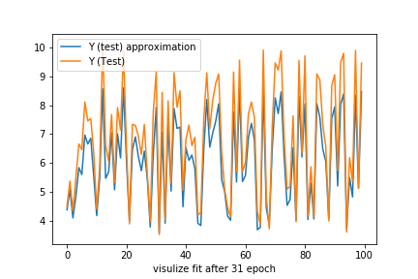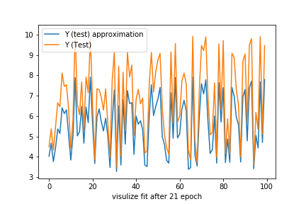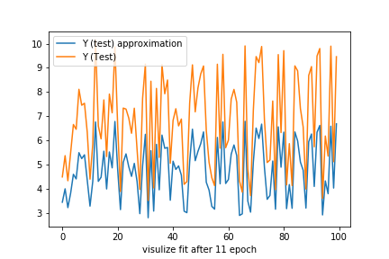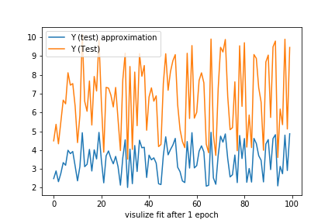5 following figures shows how regression fit evolves for TEST set as we train the model

